SmartIntern Long Term Virtual Internship on

**“Unleashing the potential of our youth: A Student performance Analysis”**

An Internship Report submitted in partial fulfillment of the requirements for award of degree of

BACHELOR OF TECHNOLOGY

IN

ELECTRONICS AND COMMUNICATION ENGINEERING

**Submitted by**

**Team ID**: LTVIP2023TMID006319

**Team size**: 5

**Team Leader**: S. Tharun Sai

**Team Member**: M. Aneel Kumar

**Team Member:** G. Jahnavi

**Team Member:** P. Nandini

**Team Member**: P. Lokesh

Faculty Mentor(s) Name: Dr. V. Sekhar, M.E., Ph.D.,



**DEPARTMENT OF ELECTRONICS & COMMUNICATION ENGINEERING**  **KUPPAM ENGINEERING COLLEGE**



**ANDHRA PRADESH 2022-2023**

**(ACADEMIC YEAR:2022-2023)**

**Unleashing the potential of our youth: A Student performance Analysis**

A country's growth is strongly measured by quality of its education system. Education sector, across the globe has witnessed sea change in its functioning. Today it is recognized as an industry and like any other industry it is facing challenges, the major challenges of higher education being decrease in students' success rate and their leaving a course without completion.

Analysing student work is an essential part of teaching. Teachers assign, collect and examine student work all the time to assess student learning and to revise and improve teaching. Ongoing assessment of student learning allows teachers to engage in continuous quality improvement of their courses. Many factors can influence a student's performance, including the influence of the parents' educational background, test preparation and so on.

The dataset contains the marks secured by 1000 students from a school. This project analyses and correlates student performance with different attributes. The analysis aims to understand the influence of important factors such as parental level of education, the status of test preparation course etc. on the performance of the students in the exams.

**Technical Architecture:**

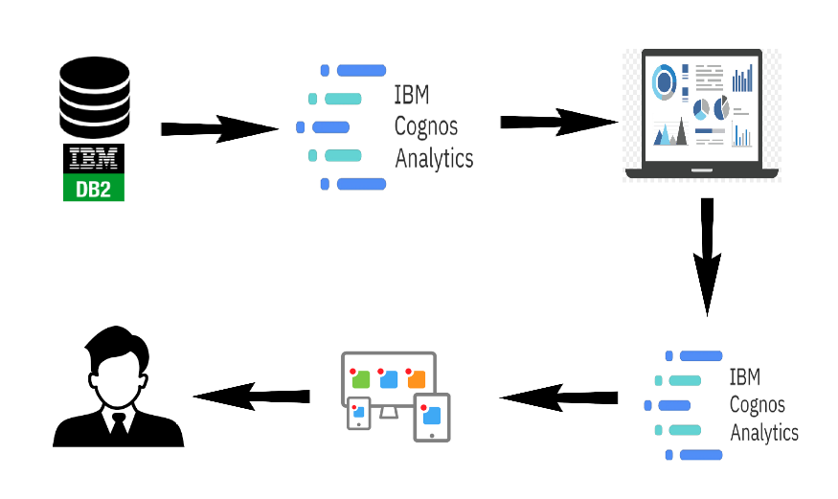

**Define Problem/Problem Understanding:**

**Business Problem:**

Choosing to take business has its benefits to individuals after they graduate, such as high-income potential, ready job market, and others. However, students have to face challenges in business school to get there. We have identified some of the common problems business students encounter before they graduate and get into the business world.

## Adjusting to New Surroundings

Many students have to move when attending business school, depending on the program they chose. A lot of students prefer choosing locations a little further from home and sometimes even across the country.

[Moving to a new city or town](https://www.oxford-royale.com/articles/move-new-city-university-student/#aId=9e05cbcb-976f-4b8e-885c-1307a65c820e) means that an individual must encounter a new environment, new people, and a new culture. Sometimes, it means getting used to a students should take a campus tour before classes start and even explore the new surroundings. Learning will be a little easier when a student is comfortable with their surroundings.

**Business Requirements:**

Business requirement of student performance analysis refers to the need of educational institutions or organizations to gather, analyse, and use data on students' academic performance to improve teaching and learning outcomes. This process involves collecting, analysing, and interpreting data on various aspects of student performance such as test scores, attendance, behavioural patterns, and demographic information. The business requirement of student performance analysis is crucial for educational institutions to provide high-quality teaching and learning outcomes and improve student success. The ultimate goal is to gain insights and improve performance through data visualization techniques.

little change in weather conditions whereby the new place might be hotter or colder than one is used to.

One might require some time to adjust to the place. It is why it’s recommended that

**Literature Survey:**

A literature survey for Student Performance Analysis involves reviewing academic articles, and other sources related to the analytics of Students Performance. Researchers and practitioners in the field are exploring new methods and tools to improve teaching and learning outcomes and provide more personalized learning experiences for individual students. The analysis can provide a comprehensive understanding of the significance, challenges, and opportunities associated with Student Performance.

**Social Or Business Impact:**

Social Impact: It have a positive social impact by improving student outcomes, promoting equity in education, and increasing transparency and accountability in the education system.

Business Model/Impact: It have a significant impact on businesses and educational institutions, as it provides valuable insights into student learning and helps improve teaching, increasing efficiency, and promoting competitiveness.

**Data Collection & Extraction from Database:**

Data collection is the process of gathering and measuring information on variables of interest, in an established systematic fashion that enables one to answer stated research questions, test hypotheses, and evaluate outcomes and generate insights from the data.

Data set link:

"C:\Users\yagna\Downloads\StudentsPerformance.csv"

**Data Preparation:**

Data modules are containers that describe data and rules for combining and shaping data to prepare it for analysis and visualization in IBM Cognos Analytics. Data module sources. Data modules can be based on data servers, packages, uploaded files, data sets, and other data modules

The data set uploaded to cognos and then created the data module and dashboard for calculations and data visualization.

### Data Visualization:

### Male Female Pass Ratio

### 

### Student by Grade

### 

### Race Specific Distribution

### 

### 

* **Parents Education**

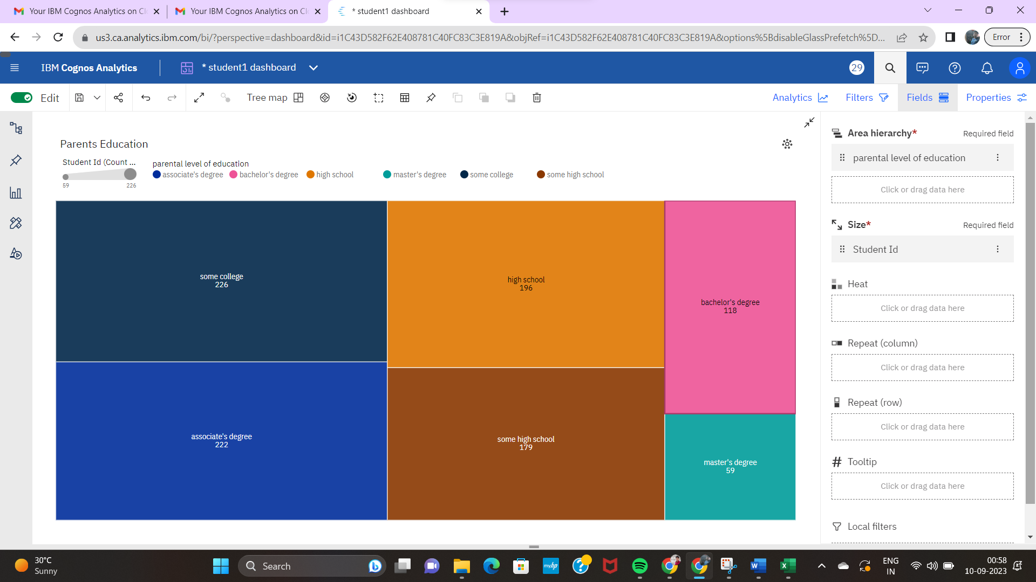

* **Test Preparation Effectiveness**

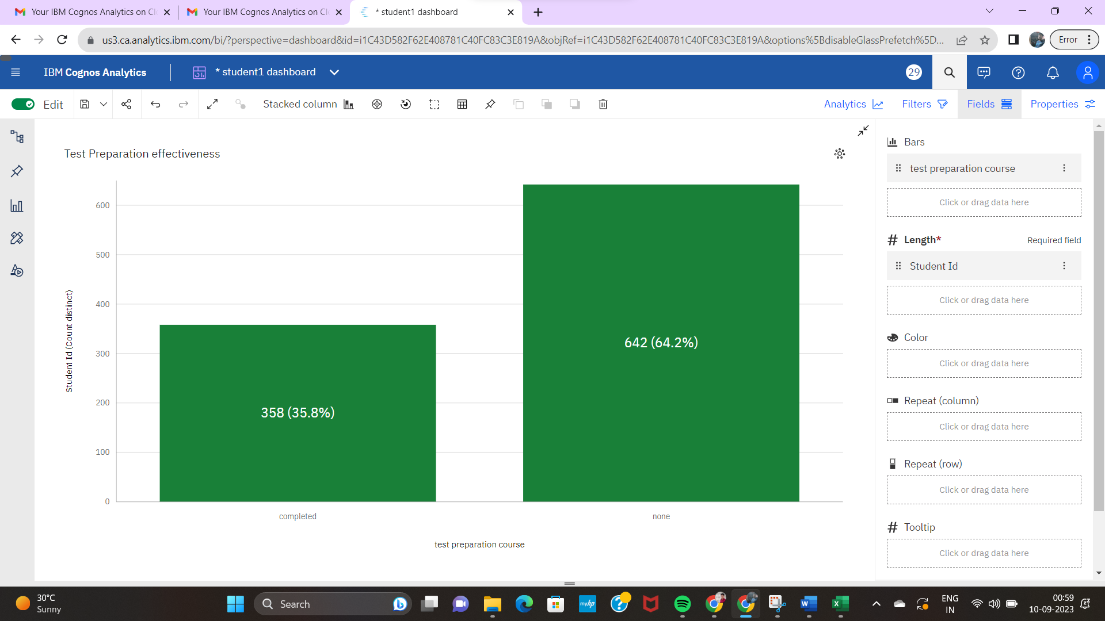

* **Grades Based on Preparation Material**

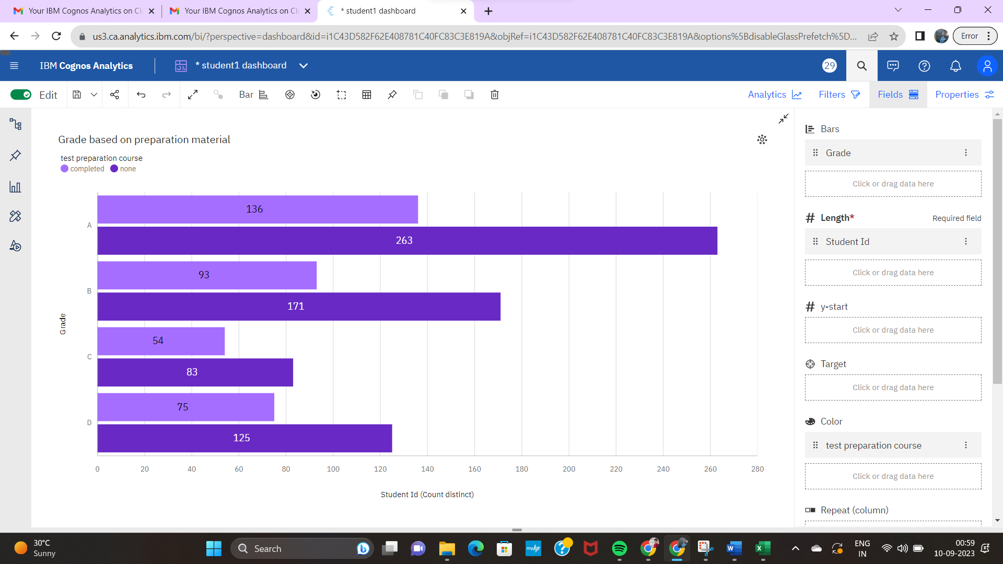

* **Race Wise Pass Fail Ratio**

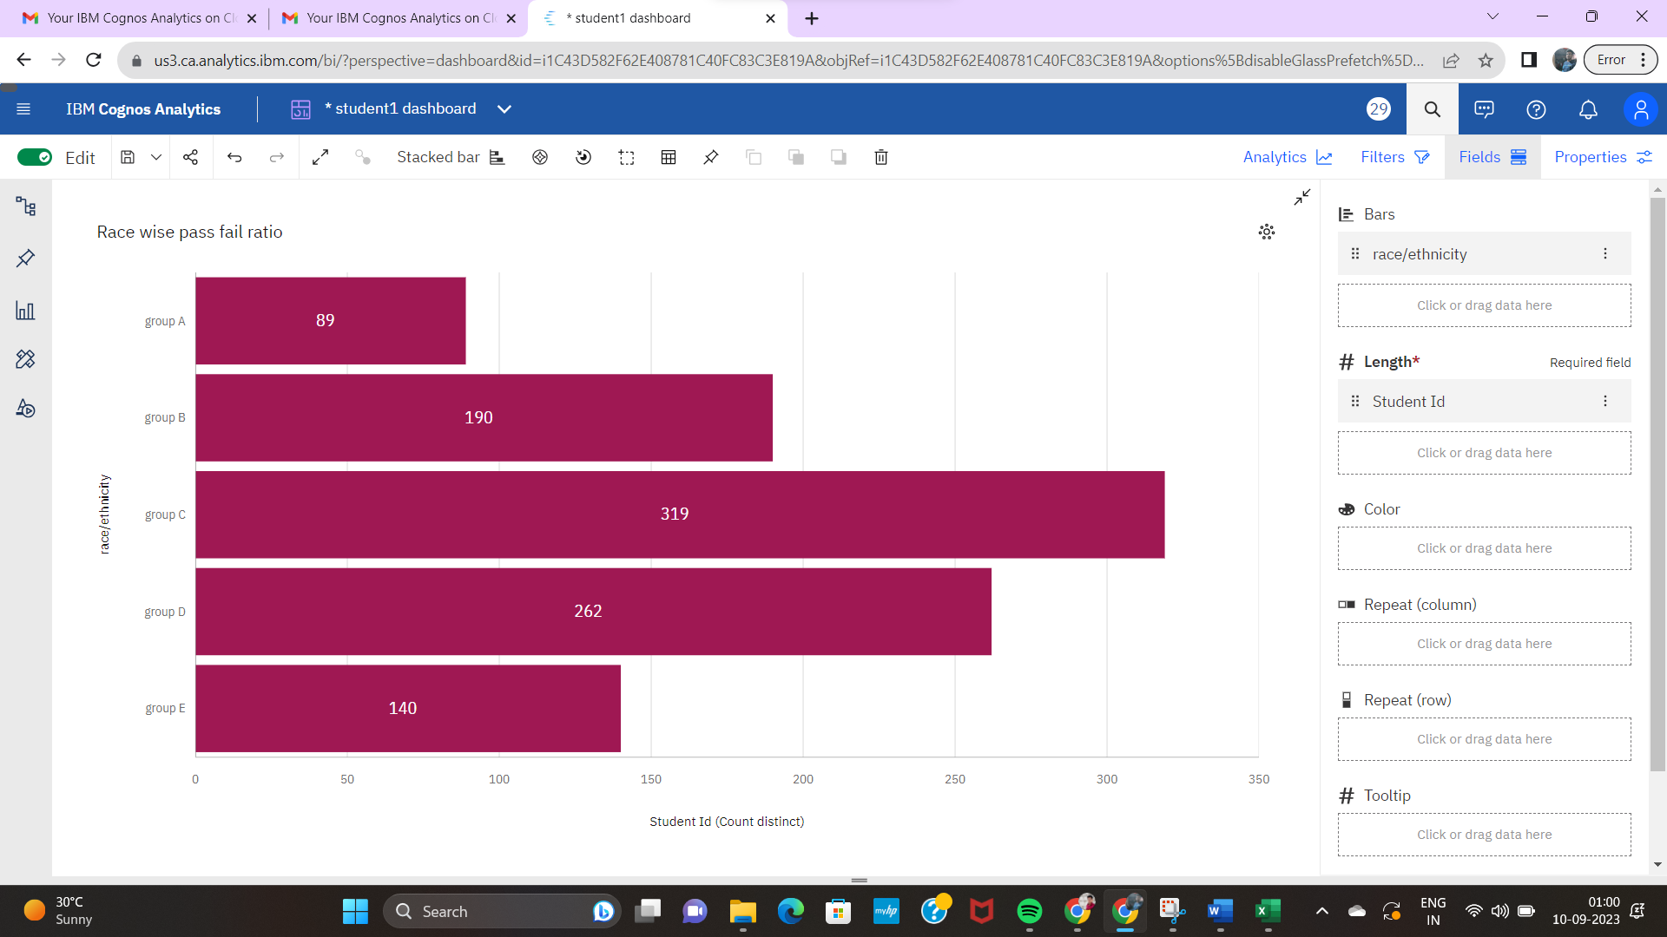

**Dash Board:**

The responsiveness and design of a dashboard for Data-Driven insights on Student Performance is crucial to ensure that the information is easily understandable and actionable. Key considerations for designing a responsive and effective dashboard include user-centered design, clear and concise information, interactivity, data-driven approach, accessibility, customization, and security. The goal is to create a dashboard that is user-friendly, interactive, and data-driven, providing actionable insights.

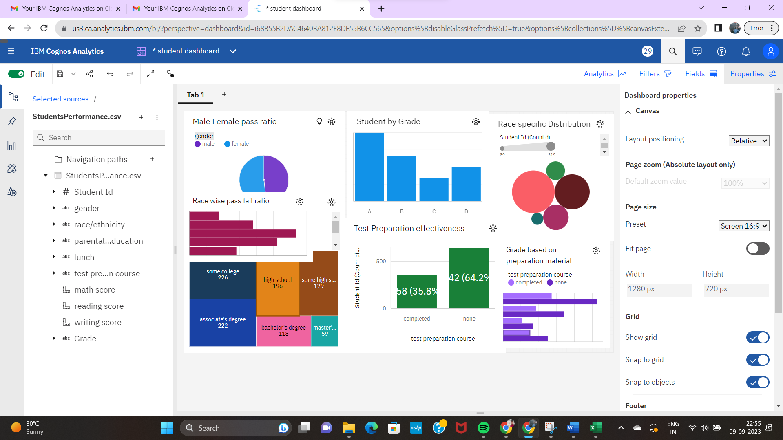

Performed the calculations based on requirements

1. Male Female Pass Ratio
2. Students By Grade
3. Race Specific Distribution
4. Parents Education
5. Test Preparation Effectiveness
6. Grades Based on Preparation Material
7. Race Wise Pass-Fail Ratio

Those are placed altogeather in the dash board.

**Story:**

A data story is a way of presenting data and analysis in a narrative format, with the goal of making the information more engaging and easier to understand. A data story typically includes a clear introduction that sets the stage and explains the context for the data, a body that presents the data and analysis in a logical and systematic way, and a conclusion that summarizes the key findings and highlights their implications. Data stories can be told using a variety of mediums, such as reports, presentations, interactive visualizations, and videos.

The number of scenes in a storyboard for Data-Driven insights on Students Performance will depend on the complexity of the analysis and the specific insights that are trying to be conveyed. A storyboard is a visual representation of the data analysis process and it breaks down the analysis into a series of steps or scenes.

After performing the data visualisation those graphs need to pined and then create the story for the data visualisation go to chrome and copy the image address of the image.

An paste the link to get the image in the story and add the title and sub title for the content of data visualisation and add all the pined images/graphs to the story.

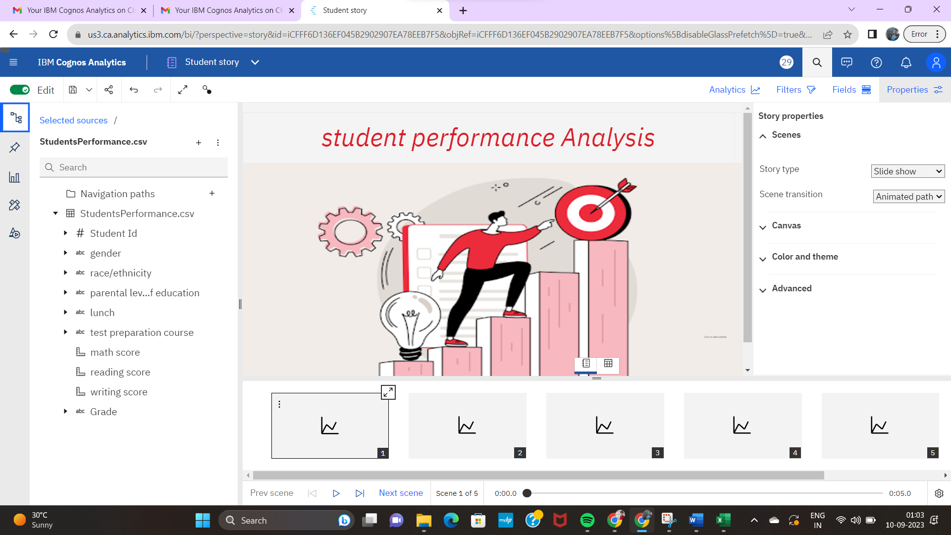

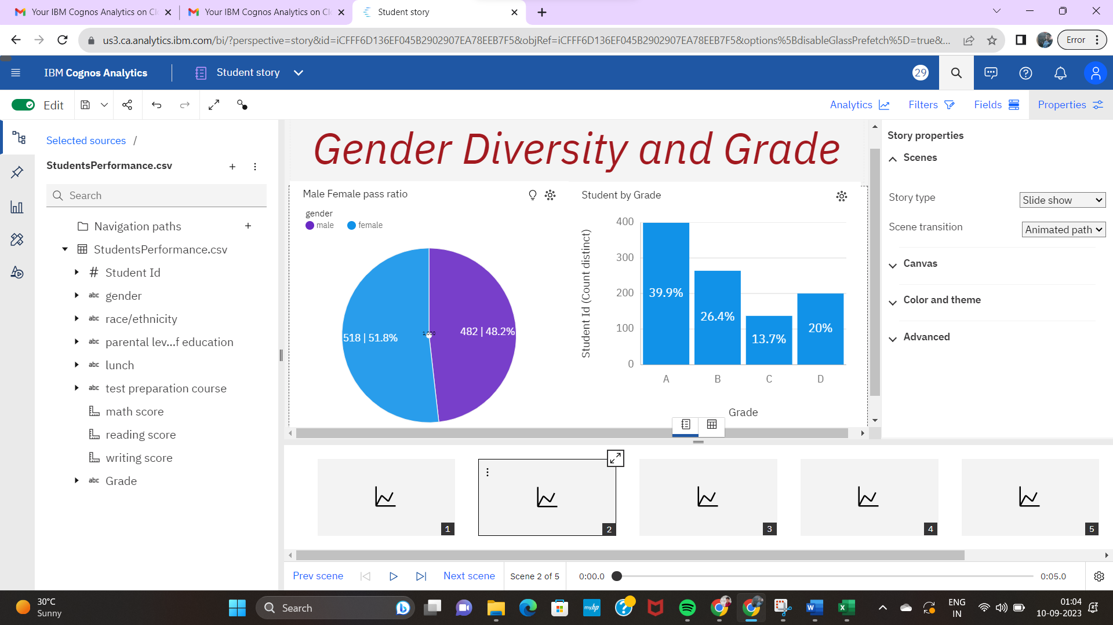

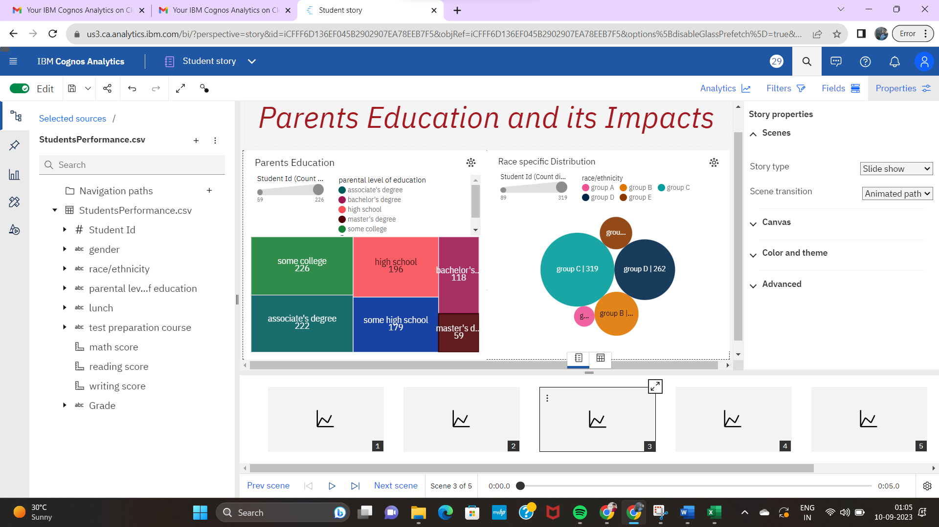

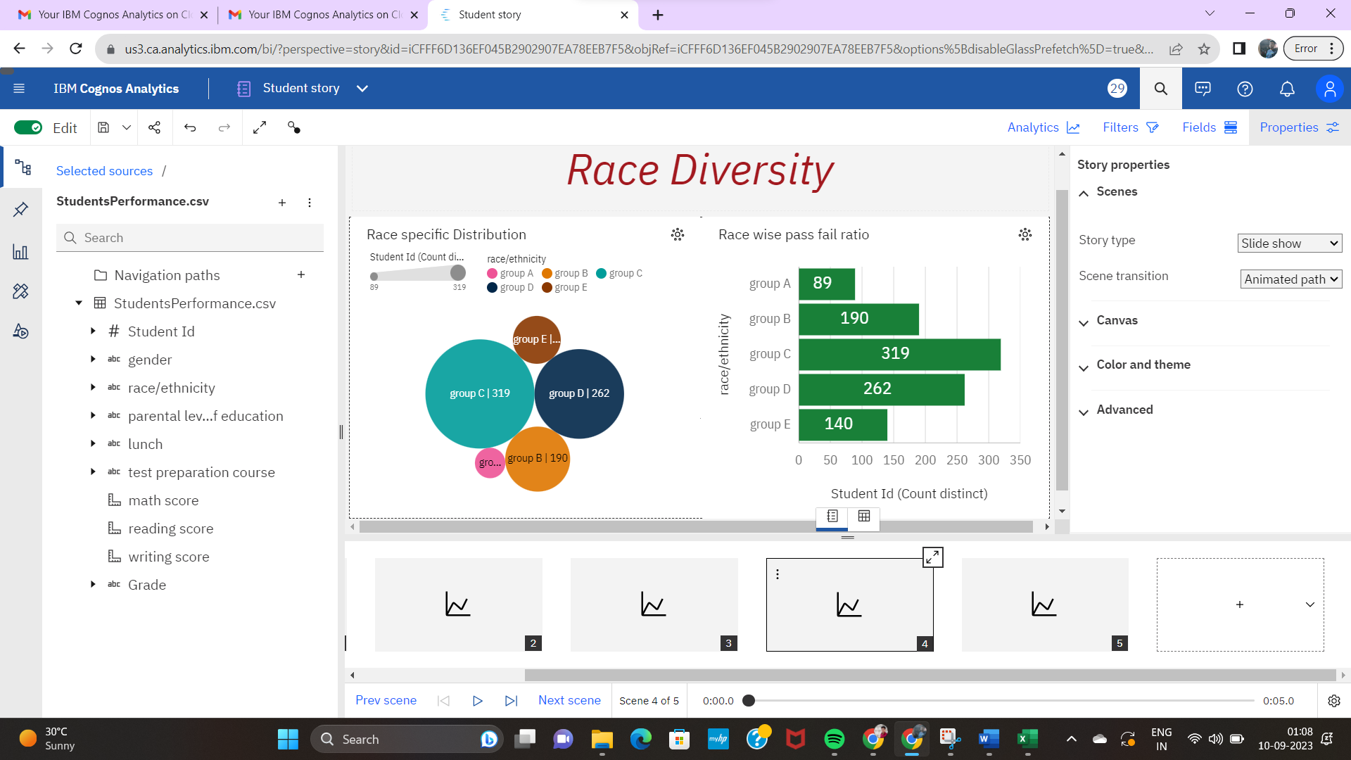

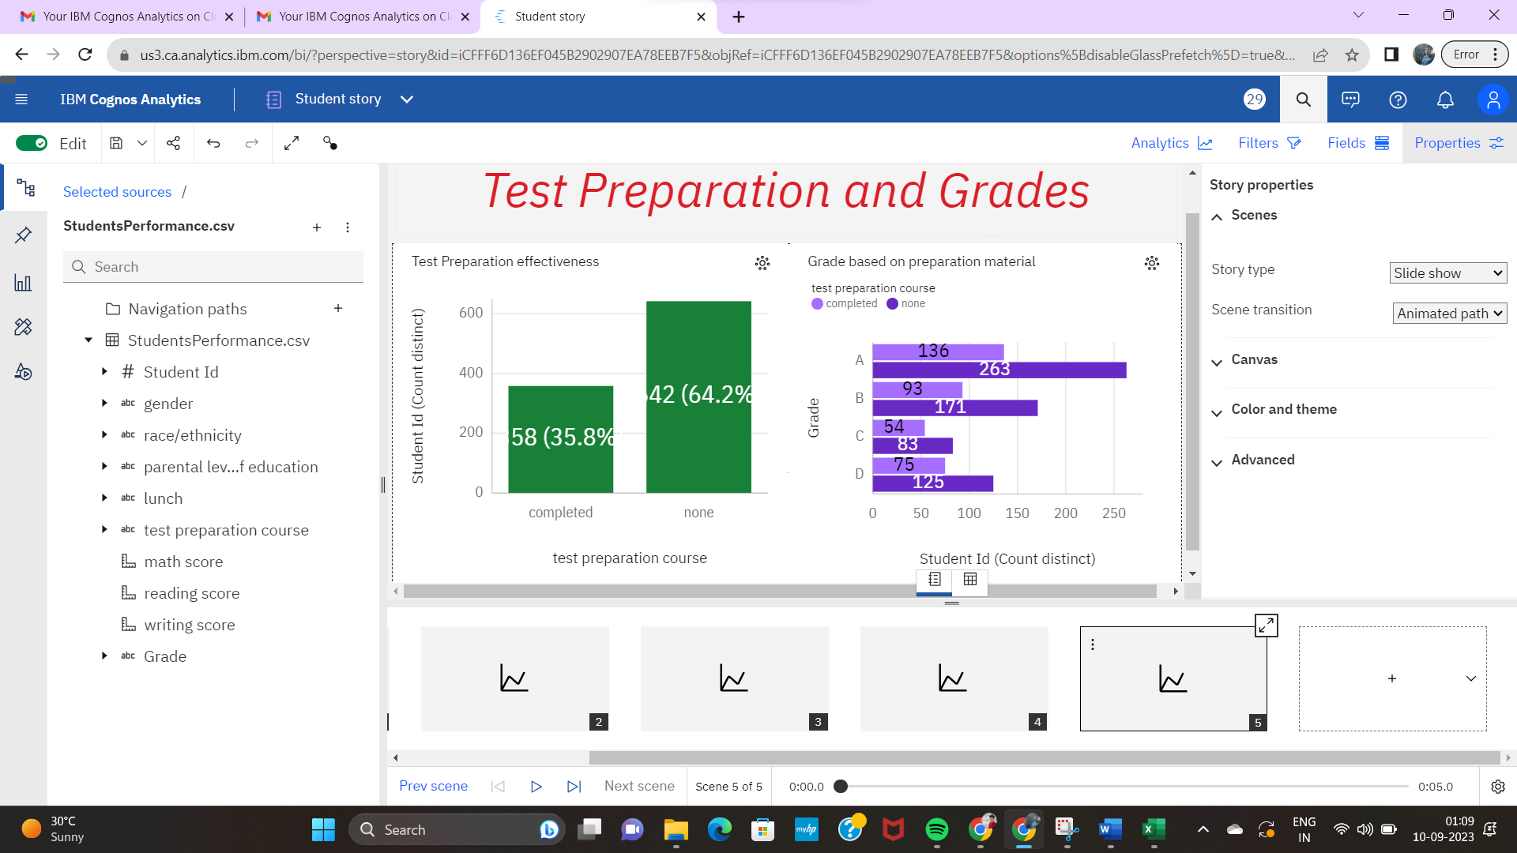

**Report:**

A report in data analytics typically involves analysing and interpreting data to draw insights and conclusions that can inform business decisions or address research questions. The report usually includes a summary of the data analysis process, including the methods and tools used, as well as the findings and recommendations based on the analysis. The report should begin with an executive summary, which provides a brief overview of the main findings and recommendations. The introduction should provide background information on the problem or research question being addressed and the data sources used.

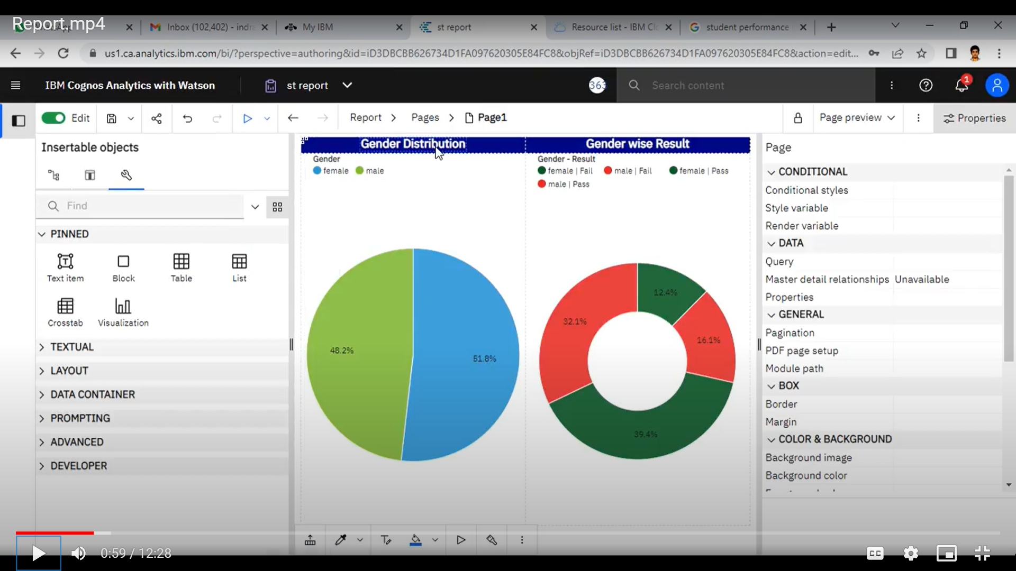

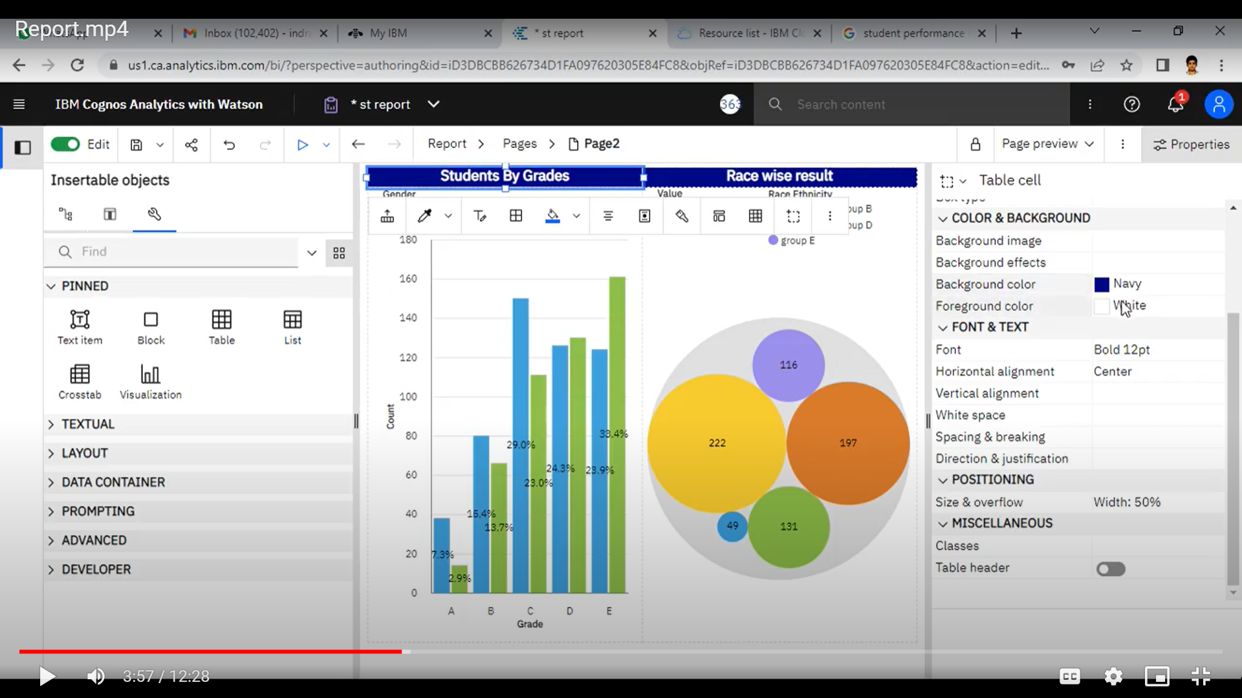

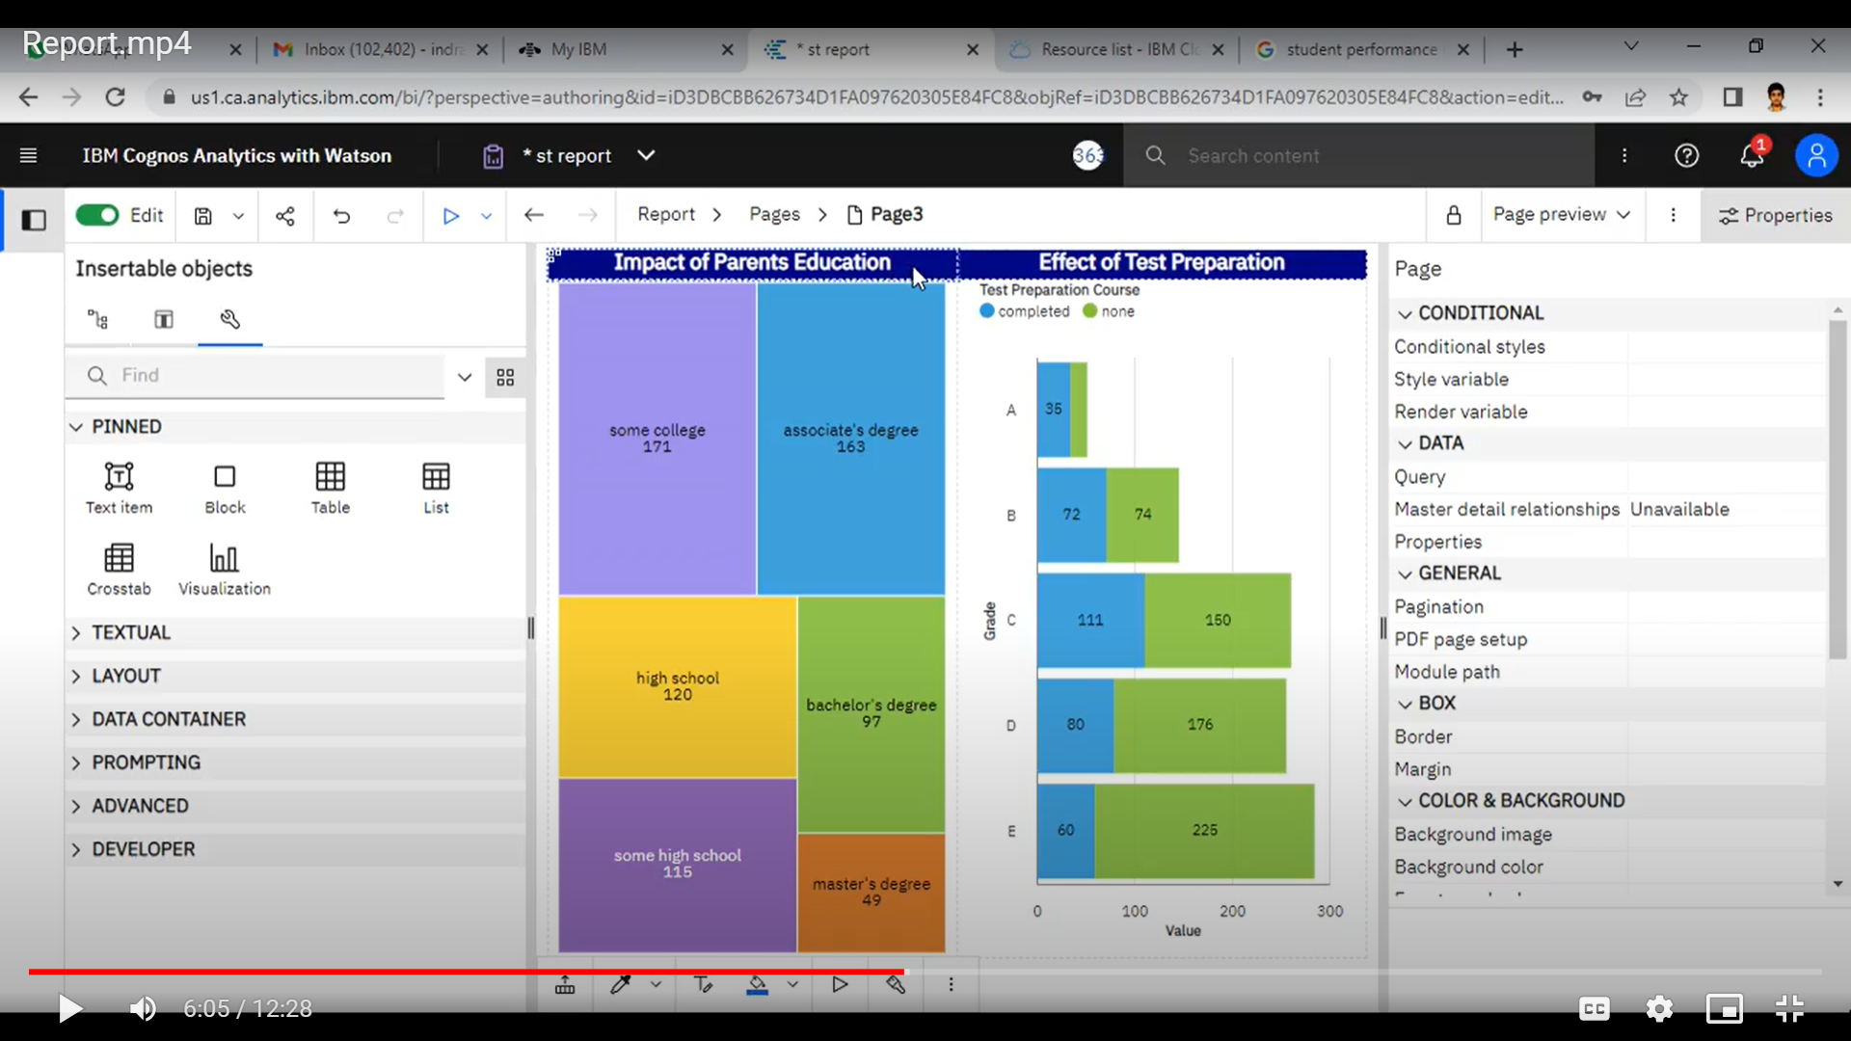

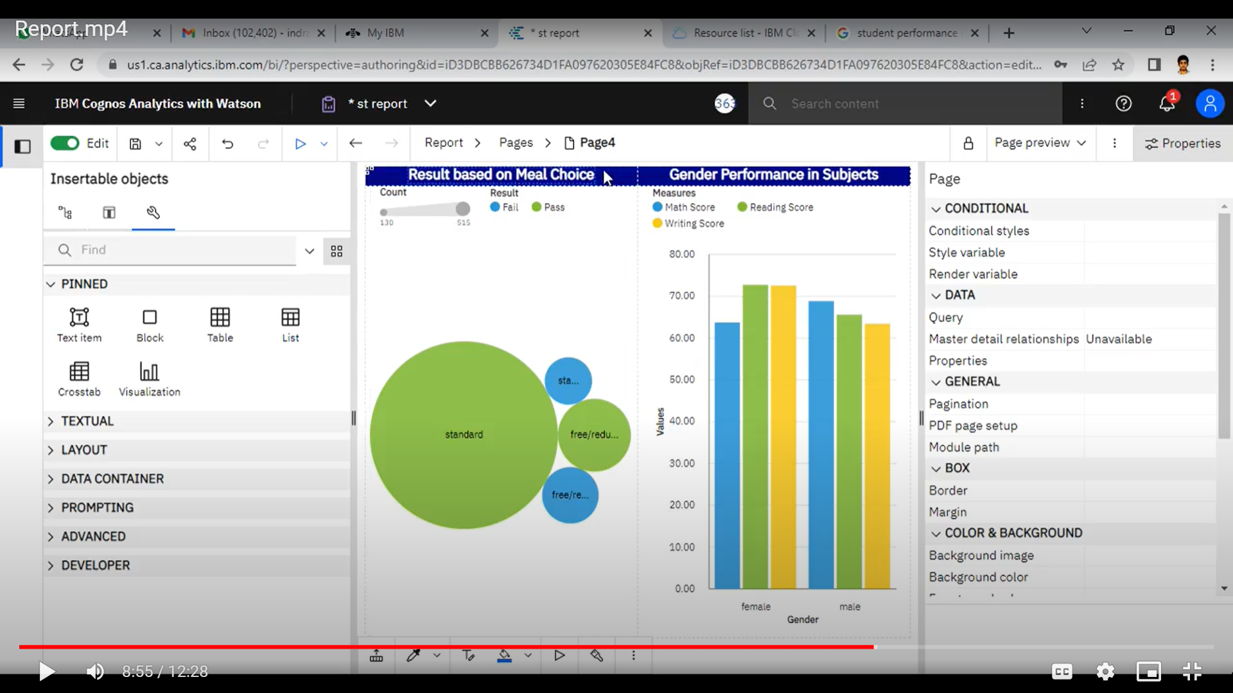

**Web Integration:**

Publishing helps us to track and monitor key performance metrics, to communicate results and progress. help a publisher stay informed, make better decisions, and communicate their performance to others.

* **Publishing dashboard, report & story.**

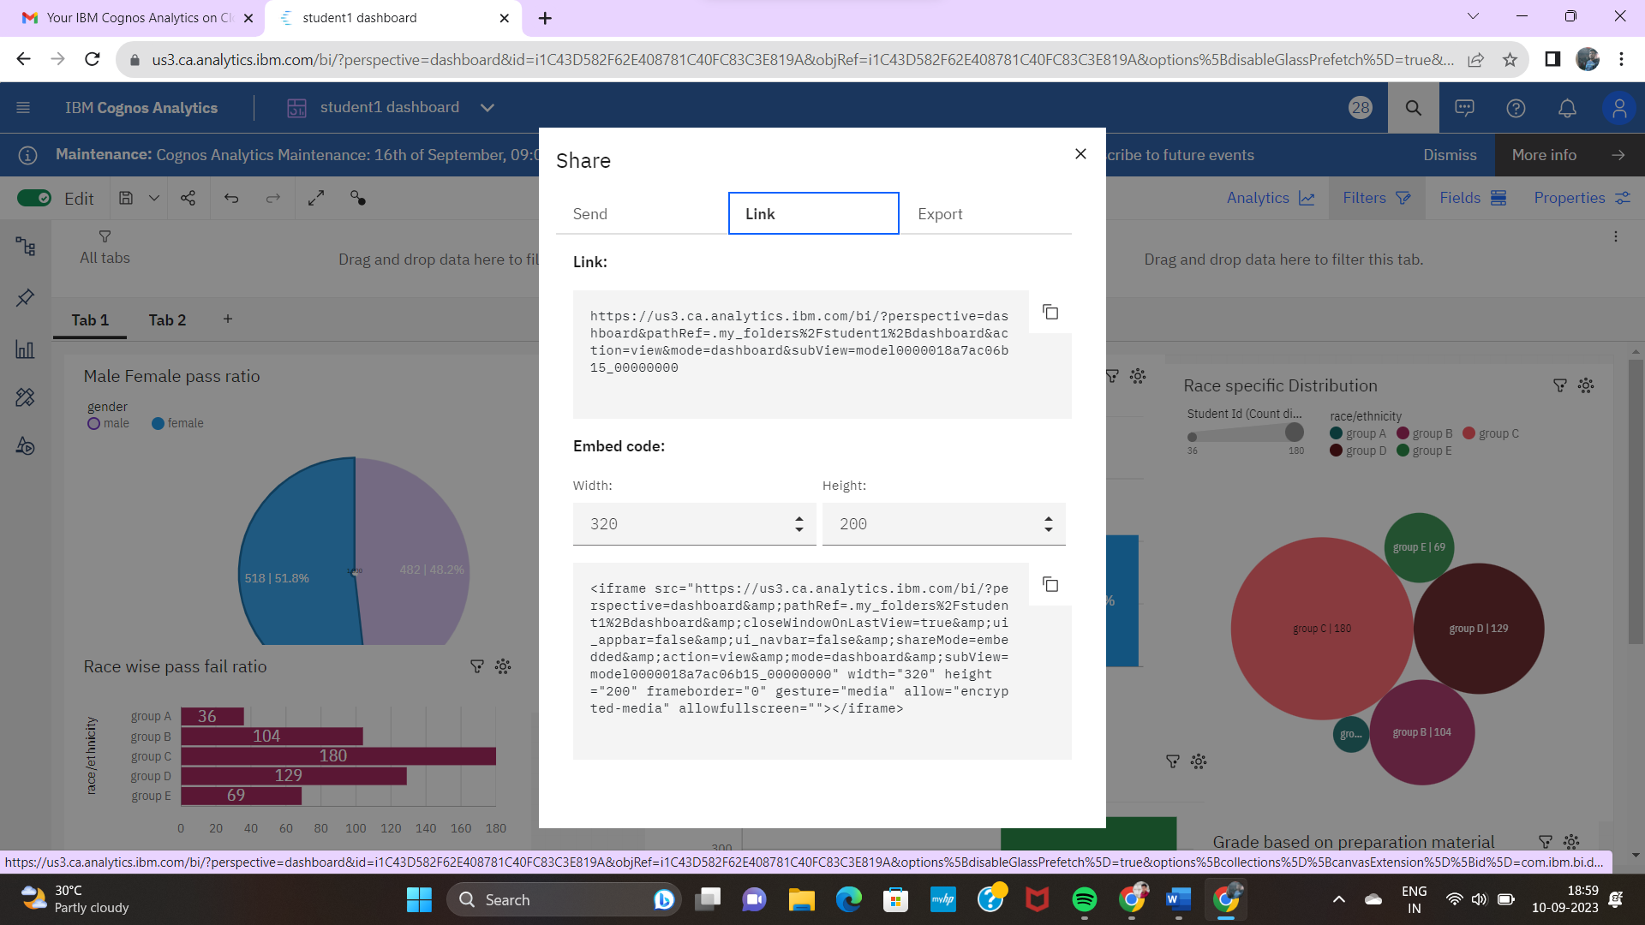

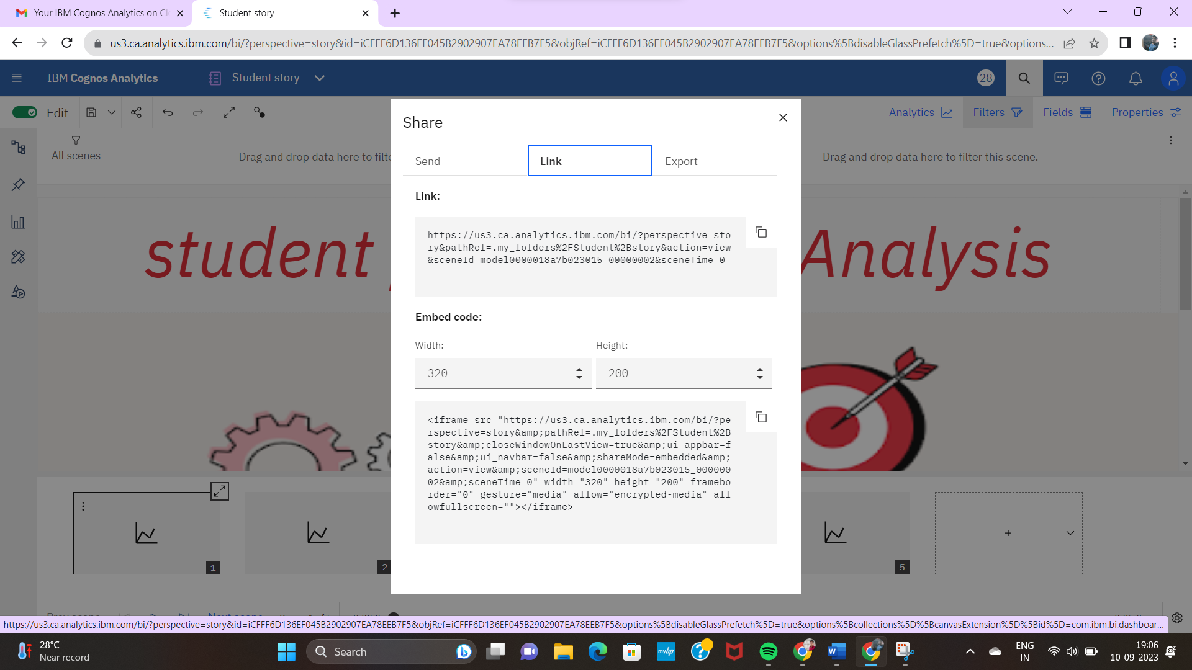

### Dashboard, Report & Story embed with UI with Flask:

### 

### 

### 

### 